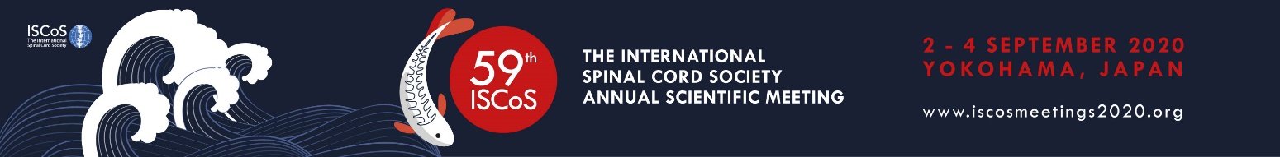

Travel funding application form for attending
The 59th International Spinal Cord Society, Annual Scientific Meeting
2 – 4 September 2020, Yokohama, Japan
- About yourself

First name
Surname
Middle name (if applicable)
Email
Qualification (highest degree)
Occupation (if more than one, please provide all, with work
percentage)
Organisation name (if more than one, please provide all)
City and Country
Occupation category | ☐ | Student trainee (registered in undergraduate, Master, PT/OT, Nursing, PhD, MD/ DO program, etc.)
 | ☐ | Postdoctoral fellow (clinical or scientific)
 | ☐ | Early career scholar (within 5 years of first academic or hospital appointment)
 | ☐ | Experienced healthcare professionals (> 5 year experience)
 | ☐ | Peer counsellor/ Consumer
 | ☐ | Other

- Involvement in ISCoS community
Please provide details and highlight key activities that you have been involved in over the last 2 years. (300 words)

Information required:
  - Describe roles, projects and activities that you have within ISCoS or its affiliated societies. Please attach your one-page CV.

Involvement at ISCoS 2020 in Yokohama, Japan
Candidates must submit an abstract to the Meeting. Or have you been invited to actively participate in a specific event, meeting or activity? (100 words)

Information required:
  - Titles of submitted abstracts and workshops and your role within the abstract/workshop
  - Titles of specific meetings or events and your role within the event

Your nominated ISCoS affiliated society/ group
Please indicate which ISCoS affiliated society/ group you are most closely associated with.
Alternatively, you can also nominate an individual that is highly involved with ISCoS, if you feel that this person is better suited to support your application than any affiliated society/ group. Please don’t nominate more than one entity or individual. You will be required to submit a statement of support from your affiliated society/ the individual.

- Benefits obtained from attendance at the ISCoS Annual Scientific Meeting How will you or your organisation benefit from your attendance at the ISCoS? Highlight in particular benefits other than obtaining/improving skills. (100 words)

Funding request from organising committee and other sources
Please provide the costs in US Dollars (USD) for attending the ISCoS Annual Scientific Meeting to be held at the Pacifico Yokohama in Yokohama, Japan. If you are planning to obtain partial or full funding from other organisations or your own institution to attend the ISCoS, please provide details of the same in column 4. If you need to convert costs in your local currency to USD, you can use this online converter: www.xe.com.

Items | Full cost (in USD) | Funding requested from organising committee (in USD) | Funding requested from other sources (in USD) | Personal contribution (in USD)
Registration fee
Flights
Accommodation
Other expenses
Visa |  | This is not covered
Travel/Health Insurance |  | This is not covered
Ground Travel |  | This is not covered

Name of organisation(s) that you have applied for funding to attend ISCoS 2020 (including your own home organisation):

